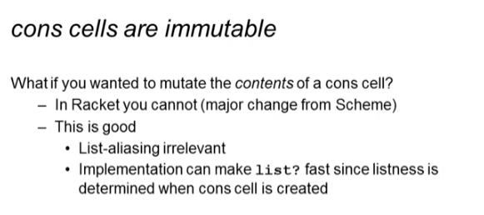

set! Does not mutate cons cells

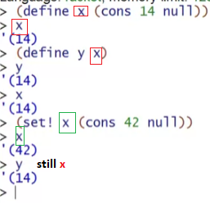



On scheme: (allows it)



**mcons** sample

* mutable cons
* just add letter m to all of its function
  + mcar
  + mcdr

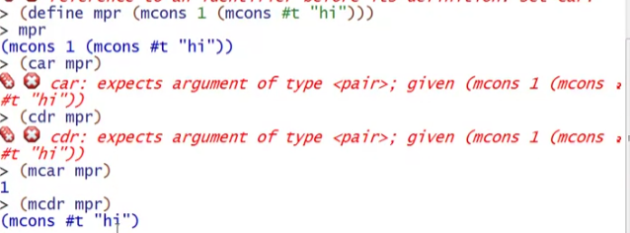

Mutating mcons

* set-mcdr! <mcons list> <your change>

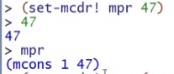

* set-mcar!

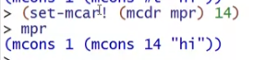

You cannot mix and match!





